Friday 28th January 2022
Good afternoon Graveley,
We, the Pupil Parliament and many of the pupils at school, have wanted to get a school animal for a while now; to help us with reading and our wellbeing. A few years ago we had a school dog called Titan and she was brilliant. In fact, it was one of the things we asked Mrs Hand about when she was interviewed for the Head teacher job here (to get another animal), she wanted a snake – interesting!
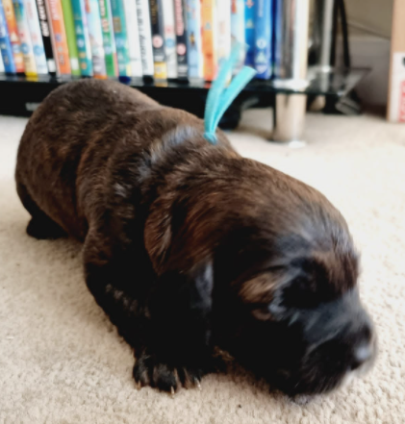
Miss Potter’s sister’s dog gave birth to a litter of puppies on January 5th and we have wondered if it was time to finally get one. This is the dog we are thinking of adopting, to become our school therapy and reading dog (he is a cocka-cava-poo and information about his parents are on the back of this letter).
We know that it is a big decision to get a dog so we have been having meetings with the teachers, researching what a therapy dog would need (training, food, vets, etc.) and what other things we have to think about, i.e. allergies, feeding him, where he would be based and poos! We also know that we need to get information and opinions from everyone in the school before we adopt.
Therefore, we have made a questionnaire for our peers, school adults and parents to fill out. Could you please fill out the answers and send it back by Friday 4th February.
We will use all of the facts and opinions to help us and update you on what has been decided.
Thank you for reading!

Yours sincerely,
Pupil Parliament
Graveley C of E Primary School

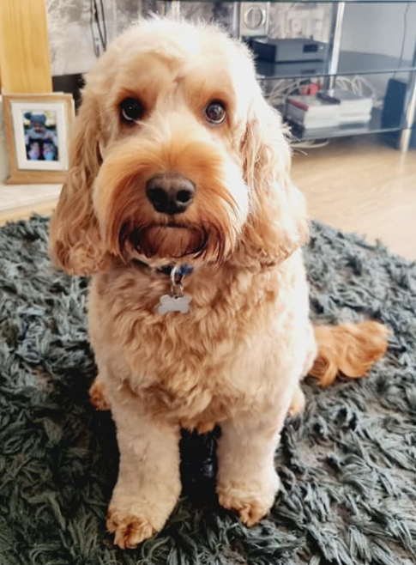
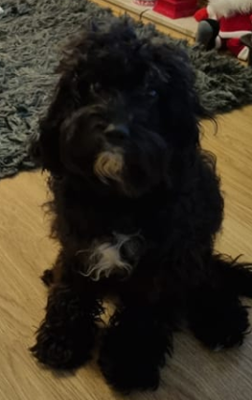

This is his dad, he is called Cooper, he is three years old and he is a Standard Cockapoo.

What is Cooper like? He is a very calm, chilled dog that follows commands really well. He loves playing with his owners children as well as the children that his human mum childminds. He sometimes shows an interest in his puppies but he generally allows Willow to do all the looking after – maybe when they are able to play more he will do a bit more with them.

What is a Cockapoo? A Cockapoo is a Cocker Spaniel Poodle mix. A mixed breed dog with one Cocker Spaniel parent and one Poodle parent. There are three types of Cocker Spaniel and Poodle mix, Toy, Mini and Standard. The only real difference is their size. This will depend on whether the spaniel parent is an American or an English Cocker. In addition, on whether the Poodle parent is a Standard, Mini, or Toy Poodle. Most common is the Mini Cockapoo dog, bred from a Miniature Poodle.

Do Cockapoos make good pets? A well-bred, well-raised Cocker Spaniel Poodle can make a wonderful addition to most families. It is important to meet the parents before choosing your puppy. This is because nice dogs generally produce nice puppies. Once your pup comes home, socialisation is key. Make sure you have many visitors, and introduce your puppy to lots of different sights and sounds. This will maximise your chance of having a friendly, confident, adult dog. Cockapoos are intelligent dogs, and children will love helping to train them. They are social dogs, and will be happiest when there is lots of company. This means they are not ideal for people who are out of the home for a lot of the day.

This is his mum, her name is Willow and she is two years old. She is a Toy Cavapoo.

What is Willow like? She has been a great mum; knowing when to clean her babies and feed them. She is well behaved and plays well with other dogs, but does not like it when her human dad comes home wearing his motorcycle helmet – she barks at him until he takes it off!

What is a Cavapoo? Also known as, a Cavoodle, the Cavapoo is a mixed breed dog with one Cavalier King Charles Spaniel parent and one Poodle parent. Breeders hope that Cavapoo puppies will unite the sweet and gentle personality of the Cavalier King Charles Spaniel with the dignified athleticism of a Poodle.

Are Cavapoos hypoallergenic? If you are looking for a hypoallergenic Cavapoo, there is no guarantee. While some people believe a Poodle’s coat is hypoallergenic, scientists say there is no such thing. The only way to determine if you will have an allergic reaction to a dog is to come into contact with it. Cavapoos generally do not shed their fur and have little dander which comes off their coats. As long as they are groomed regularly and brushed daily, they are the perfect dogs for people who may usually have allergies to pet hair and dander. However, it is not always guaranteed.

How big do Cavapoos get? Cavalier King Charles Spaniels are usually no more than about 12–13 inches high at the shoulders. Tipping the scales at 13–18 pounds, they are categorised as a toy breed. However, a big determiner of your Cavapoo puppy’s adult size will be whether their other parent was a toy or miniature Poodle. Miniature Poodles are usually about 10–15 inches tall at the shoulders and weigh 10–15 pounds.

What is a school therapy dog?
We have looked into what a school therapy dog actually is and what the benefits are of having one in a school. We found out that they are not school pets; they perform an important role, just like a member of staff!
We looked at a few different sources of information and visited sites like:
https://www.schooltherapydog.com/
https://www.hertsforlearning.co.uk/blog/school-dogs
https://time.com/4728315/science-says-pet-good-for-mental-health/
https://www.theforestschooldogs.com/
A therapy dog can help with attendance; all schools have some children who find it difficult to get to school and sometimes having a friendly loving animal, which people know do not judge, can help them come in and feel more at ease and be ready to learn.
The animals can also improve the wellbeing of children as well as the adults in school. We have all found the last few years an extremely challenging time. A dog can help with initially making us feel happy and smiley and, if we are struggling, we can do a number of activities with it to help us feel better and ready to learn. However, we know that it is not a toy and something we can just do in order to get out of class for!
Being a reading buddy is another brilliant job that they have. Some pupils find it very challenging and scary to read to another person, even if it is an adult or other pupil we trust. Having an animal to read to can help with our confidence and we know that they will love us no matter what, so we are more likely to feel comfortable for it to listen to us read, even if it may not understand all the words.
There are so many other benefits, which we haven’t found out yet or learnt through Therapy dog training, but we will look into that more if or when we have finalised our decision on adopting a dog.
We also have looked into other schools in Stevenage who have therapy dogs, if you would like to have a look at their websites here are the links:
https://www.barnwellschool.co.uk/index.php/about-us/colleges/therapy-dog/
https://thenobelschool.org/our-school-dog/
https://www.longmeadow.herts.sch.uk/page/?title=Our+School+Dog&pid=97
https://www.crabtreejm.herts.sch.uk/wellbeing-and-mental-health/school-dog
We hope that you have found this information useful and found the links we have given helpful.
School Therapy Dog Questionnaire
To be returned by Friday 4th February
1) Do you have a dog of your own at home?
If so what breed do you have?

2) Do you or your child/ren have a phobia of dogs?

3) Do you or your child/ren have an allergy to dogs?
If so how severe? (e.g. are you affected by being in the same room/ having the fur on you or your clothes etc.)

4) What questions do you have about the school possibly getting a therapy dog?

Name: .

