EYFS (Reception) Cycle B
2022/23 and 2024/25
 | English | Maths | Science | Art | DT | Music
Autumn Term  Me and My Community    History Focus  Me and My Community    History Focus  Companion Projects  - Move it!  - Animal Safari  - Colour and drawing  - Remarkable Recipes (skills) | Biographies; Newspaper reports; Posters; Speeches | Subitising; counting; comparison; pattern; Classification | Move it!  Exercise; Sleep; Balanced diet  Habitats  Animals around the world; How to look after animals | Colour mixing; Colour wheel; Primary and secondary colours.  Drawing | Sources of food; Kitchen tools; Reading recipes; Hygiene rules; Making a school meal | Ho, ho, ho!  Listening and appraising music)  Singing together - Ho, ho, ho song. Plus Christmas production songs
 | Computing | Geography | History | PSHE | RE | PE
 | Staying safe online;  Creating/patterns; | Caring for the environment; Our local area; maps; Weather | Our School; Our community | Being Me in My World  Celebrating Difference | Creation  Christmas | First PE skills  Fairy tale dance
Memorable Experience
Studying a local historically significant person.
Details to be added when confirmed

Spring Term  On the Beach    Geography Focus  Splash    Science Focus  Companion Projects  - Beach Hut  - Flower Head  - Use of materials  - Plant survival | English | Maths | Science | Art | DT | Music
 | Descriptions; Adventure narratives; Non-chronological reports; Persuasive writing | Counting; Comparing; spatial thinking; Ordering and estimating; regrouping the whole; Regrouping parts | Use of materials  Identifying materials and their properties; Uses of materials; Melting and freezing  Ready, steady, grow  Plant parts; What plants need to grow; Lifecycles | Flowers  Cutting; Joining | Making Ice Lollies  Recipes; Melting and freezing | Glockenspiel Stage 1  Improvise using notes, D, E and F. Play one of the differentiated parts following simple melody using notes C, D, E, F
 | Computing | Geography | History | PSHE | RE | PE
 | Spring time; Uses of technology; Algorithms | Maps, Places; Maps; Weather | Changes over time; | Dreams and Goals  Healthy Me | What do Christians believe? Celebrations  Easter | Gymnastics  Multi Skills
Memorable Experience
Coastal visit.
Details to be added when confirmed
Summer Term  Magnificent Monarchs  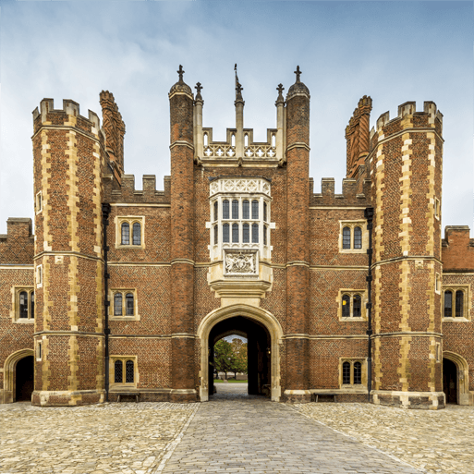  History Focus  Companion Projects  - Marvellous Machines  - Cut, stitch and join  - Animal survival  - Portraits | English | Maths | Science | Art | DT | Music
 | Information leaflets; Poetry; Story writing | Ten and some more; Doubling and halving; Odd and even; Counting beyond twenty | Animal Survival  Types of animals; What animals need | Royal portraits; | Cut, Stitch and Join  Types of stitches  Marvellous Machines  Designing and Making  Construction; Joining | Glockenspiel Stage 2  Learning the language of music through the glockenspiel. Beginning to use musical score.
 | Computing | Geography | History | PSHE | RE | PE
 | Summer fun  Tinkering; Persevering; Patterns; Logic; Decomposition; Debugging; Collaborating; Algorithms | Significant places – royal residences | Kings, Queens, Castles, Significant people | Relationships  Changing Me | Judaism | Enjoy a ball  Athletics
Memorable Experience
English and British monarchy timeline.
Details to be added when confirmed

