EYFS (Reception) Cycle A
2023/24 and 2025/26
 | English | Maths | Science | Art | DT | Music
Autumn Term  Long ago  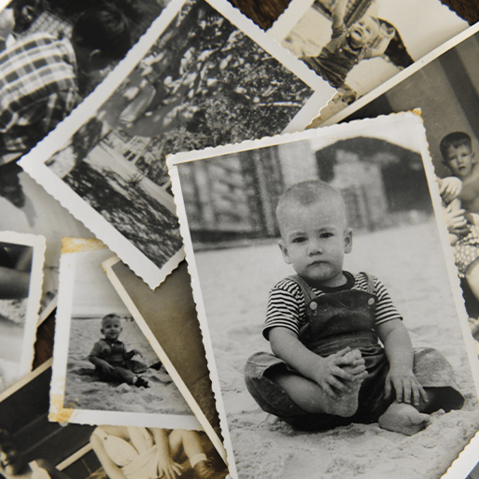  History Focus  Long ago  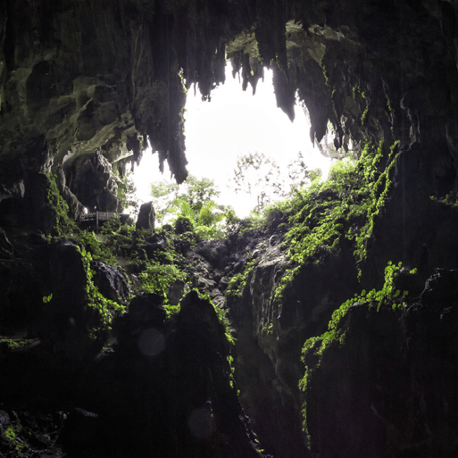  Geography Focus  Companion Projects  - Colour and drawing  - Everyday Materials  - Human Senses | Autobiographies; Non-chronological reports; Riddles; story writing | Subitising; counting; comparison; pattern; Classification | Everyday Materials  Naming everyday materials; Properties and uses of materials  Human Senses  Body parts; What are the sense? How do we use them? | Colour mixing; Colour wheel; Primary and secondary colours.  Portraiture; | Homes –  Investigating; Designing and making; Safety rules; Materials.  Funny Faces  Drawing; portraits | In the Groove  Listening and appraising music  Singing together - In the groove song. Plus Christmas production songs
 | Computing | Geography | History | PSHE | RE | PE
 | Staying safe online;  Creating/patterns; | Where we live; school; maps; journeys | Families; schools; toys; transport; growth | Being Me in My World  Celebrating Difference | Creation  Christmas | First PE skills  Fairy tale dance
Memorable Experience
Childhood past and present
Details to be added when confirmed

Spring Term  Bright Lights, Big City    Geography Focus  Companion Projects  - Taxi (Making vehicles)  - Printing  - Seasonal Changes | English | Maths | Science | Art | DT | Music
 | Information posters; Directions; Story writing | Counting; Comparing; spatial thinking; Ordering and estimating; regrouping the whole; Regrouping parts | Signs of Spring  Weather; Signs of spring; Changes;  Puddles and Rainbows  Weather: Rainbows | Printing | Taxi!  Designing; Joining; Painting; Colour | The Dragon Song  Learn and perform song together and accompany with glockenspiels and percussion instruments
 | Computing | Geography | History | PSHE | RE | PE
 | Spring time; Uses of technology; Algorithms | Cities; London: Landmarks: Maps | Changes over time; Significant events | Dreams and Goals  Healthy Me | What do Christians believe? Celebrations  Easter | Gymnastics  Multi Skills
Memorable Experience
Royal Role Play
Details to be added when confirmed
Summer Term  School Days  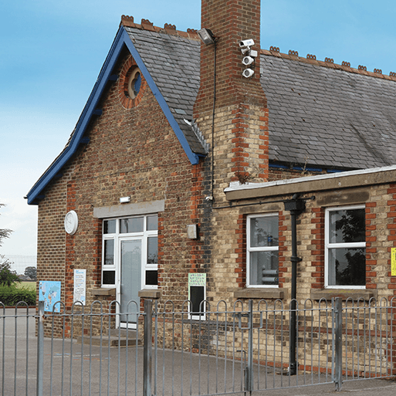  History Focus  Companion Projects  - Street View (houses)  - Chop, slice and mash  - Creep, crawl and wiggle  - Sunshine and sunflowers | English | Maths | Science | Art | DT | Music
 | List poems; Diaries; Letters | Ten and some more; Doubling and halving; Odd and even; Counting beyond twenty | Sunshine and flowers  Parts of a plant; What they need to grow: Lifecycles  Creep, Crawl and Wiggle  Types of animals; What animals need | Houses  Designing; joining; making; materials | Chop, Slice and Mash – Cooking skills; Where food comes from | Zootime  Learn and perform this reggae song together and accompany with glockenspiels and percussion instruments
 | Computing | Geography | History | PSHE | RE | PE
 | Summer fun  Tinkering; Persevering; Patterns; Logic; Decomposition; Debugging; Collaborating; Algorithms | Our school; Maps | Changes over time; Family; Schools | Relationships  Changing Me | Islam | Enjoy a ball  Athletics
Memorable Experience
Our school’s history

