Upper Key Stage 2 (Year 5 and Year 6) Cycle B
2022/23 and 2024/25
 | English | Maths | Science | Art | DT | Music
Autumn Term  Maafa  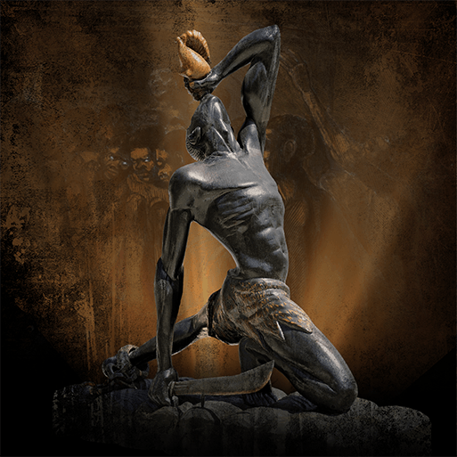  History Focus  Companion Projects  - Tints, tones and shades  - Food for Life  - Our Changing World  - Trail Blazers, Barrier Breakers  - Circulatory Systems | Newspaper reports; Persuasive letters; Non-chronological reports; Acrostic poems | Number and Place Value Reasoning  Multiplicative Reasoning 1 (Multiply and Divide by Powers of Ten)  Additive Reasoning 1  Number Properties Reasoning  Multiplicative Reasoning 2 (Multiplication)  Fraction Reasoning 1  Multiplicative Reasoning 3 (Division)  Algebraic Reasoning 1 | Circulatory Systems  Unit not yet released | Colour theory; Colour wheel; Mixing tints, shades and tones; Landscapes.  Trailblazers, Barrier Breakers  Significant black artists; Analysing artwork; Creating artwork with meaning | Whole foods; Processed foods; Making healthy meals; Hygiene and safety | Beginner Keyboard Course.
 | Computing | Geography | History | PSHE | RE | PE
 | Staying safe online; Evaluating Digital Content  Scratch, algorithms and debugging | Africa – countries, land use, natural resources, location, settlements, population, climate and physical features.  Our Changing World  Features of Earth including the Arctic and Antarctic Circles; Time zones, Latitude and longitude; Map scale; Grid references, contours and symbols; Climate change, extreme weather and people; Worldwide trade; Natural resource management; Road safety; Fieldwork; Settlement patterns; Local enquiry | Ancient African kingdoms; Development of the transatlantic slave trade; Britain's role in the slave trade; Human impact; Everyday life on plantations; Rebellion and marronage; Causes and consequences of the abolition of the slave trade and slavery; Colonisation of Africa; Black people in 20th century Britain; Race Relations Act; Equality Act; Significant black Britons; Multiculturalism | Being Me in My World  Celebrating Difference | Christianity and Buddhism  Christian and Buddhist beliefs and practices.  The Buddha  Christmas | Dance -  Dance Unit  Stomp Dance Unit  Games -  Basketball Unit  Tag Rugby Unit
 | Memorable Experience  Exploring Africa today  Details to be added when confirmed |  |  | Innovate Challenge  Inspirational black Britons
Spring Term  Frozen Kingdom  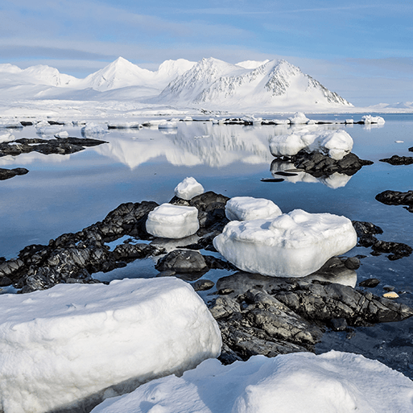  Geography Focus  Companion Projects  - Inuit  - Engineer  - Environmental Artists  - Electrical Circuits and Components | English | Maths | Science | Art | DT | Music
 | Non-chronological reports; Haiku poetry; Newspaper reports; Adventure narratives | Geometric Reasoning 1  Proportional Reasoning 1 (Percentages)  Multiplicative Reasoning 4 (Division)  Spatial Reasoning 1 (Area and Perimeter)  Fraction Reasoning 2 (Multiplying and Dividing with Fractions)  Spatial Reasoning 2 (Volume)  Proportional Reasoning 2 (Ratio and Scaling)  Positional Reasoning (Angles and Translation) | Classifying living things; Classification keys; Adaptation; Investigations.  Electrical Circuits and Components  Series circuits; Circuit components; Recognised circuit symbols; Investigating circuit components; Electric current; Voltage; Researching cells and batteries; Investigating voltage changes; Working scientifically – Identifying and classifying, Pattern seeking, Comparative test, Research | Inuit  Printmaking; Carving.  Environmental Artists  Environmental art; Recycled, reused and repurposed materials | Engineer  Significant engineers and bridges; Features of bridges; Strengthening techniques; Iterative design; Building prototypes.  Electrical Circuits and Components  Sensors and monitoring; Designing and making home devices; Incorporating programming and circuits in products | The Fresh Prince of Belair  learning to sing, play, improvise and compose hip hop with the theme song from Fresh Prince of Belair,
 | Computing | Geography | History | PSHE | RE | PE
 | Environmental Artists  Video editing software.  Electrical Circuits and Components  Programming; Animating LEDs; Introducing repeats; Sensors and monitoring | Arctic and Antarctic regions; Lines of latitude and longitude; Polar climates; Polar day and night; Polar oceans; Polar landscapes; Climate change; Natural resources; Indigenous people; Tourism | Polar exploration; Significant people – Robert Falcon Scott; Ernest Shackleton; Significant events – Titanic | Dreams and Goals  Healthy Me | Christianity and Buddhism Expressing faith in art, drama and song.  The importance of Jesus to Christians | Gymnastics -  Unit 1  Unit 2  Fitness Unit  Indoor Athletics
 | Memorable Experience  Polar expedition  Details to be added when confirmed |  |  | Innovate Challenge  Discovering the Arctic
Summer Term  Britain at War  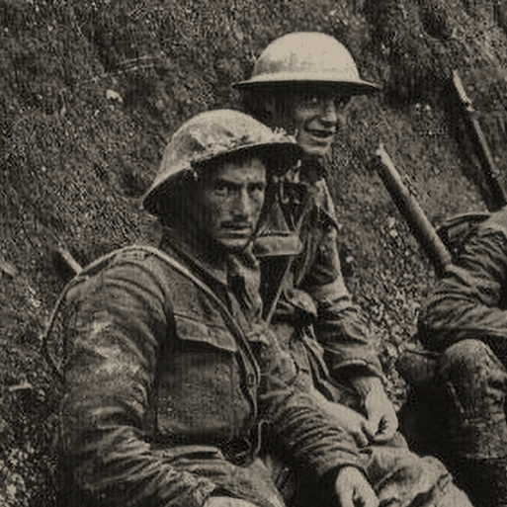  History Focus  Companion Projects  - Make do and mend  - Distortion and Abstraction  - Light Theory  - Bees, Beetles and Butterflies  - Evolution and Inheritance | English | Maths | Science | Art | DT | Music
 | Persuasive posters; Historical narratives; Nonets | Statistical Reasoning 1  Roman Numerals, Time and Revision  Proportional Reasoning 3  Statistical Reasoning 2  Measures and Describing Patterns  Financial Maths and Enterprise  Solving Problems involving the Four Operations | Light Theory  Light facts; How light travels; Light, sight and the human eye; Visible light; Perceiving colour; Shadows; Reflections; Plane, concave and convex mirrors; Measuring light; Refraction; Working scientifically – Identifying and classifying, Comparative tests, Pattern seeking, Research  Evolution and Inheritance  Unit not yet released | Distortion and Abstraction  Abstract art; Abstraction by line, colour and shape; Significant artists – Pablo Picasso, Robert Delaunay and Sonia Delaunay; Orphism.  Bees, Beetles and Butterflies  Using sketchbooks; Observational drawing; Mixed media collage; Pop Art | Make Do and Mend  Investigating clothing; Sewing – running stitch, whip stitch and blanket stitch; Repairing clothes; Making products from recycled materials | Gaining Confidence through Performance
 | Computing | Geography | History | PSHE | RE | PE
 | Programming | Place and interconnections; Maps | First and Second World Wars; Causes; Warring nations; Weaponry, warfare and technology; Key events and battles; Impact on citizens and everyday life; Significant leaders; End of war; Local history study; Remembrance; Post-war Britain | Relationships  Changing Me | Christianity and Buddhism  Ideas about God  Human responsibility for the environment  Suffering | Outdoor and Adventurous Activities Unit  Athletics Unit  Tennis Unit  Rounders Unit
 | Memorable Experience  War museum  Details to be added when confirmed |  |  | Innovate Challenge  Memorial books

