Upper Key Stage 2 (Year 5 and Year 6) Cycle A
2023/24 and 2025/26
 | English | Maths | Science | Art | DT | Music
Autumn Term  Dynamic Dynasties  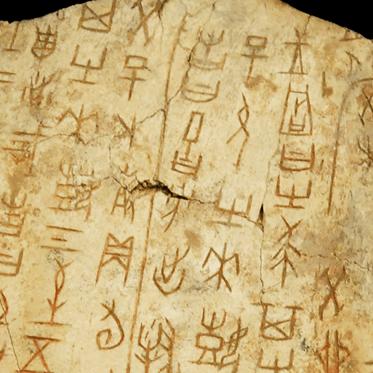  History Focus  Companion Projects  - Tints, tones and shades  - Moving mechanisms  - Investigating our World  - Taotie  - Forces and Mechanisms  - Earth and Space | Narrative poems; Biographies; Stories from another culture | Number and Place Value Reasoning  Multiplicative Reasoning 1 (Multiply and Divide by Powers of Ten)  Additive Reasoning 1  Number Properties Reasoning  Multiplicative Reasoning 2 (Multiplication)  Fraction Reasoning 1  Multiplicative Reasoning 3 (Division)  Algebraic Reasoning 1 | Forces and Mechanisms  Unit not yet released  Earth and Space  Unit not yet released | Colour theory; Colour wheel; Mixing tints, shades and tones; Landscapes.  Taotie  Taotie motifs; Casting methods; Watercolour | Moving Mechanisms  Pneumatic systems; Joining and finishing; Iterative design process; Building pneumatic machine prototypes | Beginner Keyboard Course.
 | Computing | Geography | History | PSHE | RE | PE
 | Staying safe online; Evaluating Digital Content | Investigating Our World  Ordnance Survey maps; Contour lines; Six-figure grid references; Time zones; Climate zones; Vegetation belts; Biomes; Human geography; World cities; Sustainable manufacturing processes; Relatives locations and distances; Transport networks; Settlement hierarchy; Local enquiry; Fieldwork | Ancient China; Timelines and chronology; Shang Dynasty; Sources and artefacts; Oracle bones and religious beliefs; Bronze Age in ancient China; Historical enquiry; Significance of jade and silk; Power and social hierarchy; Everyday life; Warfare; Significant individual – Di Xin; End of the Shang Dynasty; Bronze Ages around the world; Life after the Shang Dynasty; Legacy | Being Me in My World  Celebrating Difference | Christianity and Judaism  Rules for living  Light as a symbol  Christmas | Dance -  Dance Unit  Stomp Dance Unit  Games -  Basketball Unit  Tag Rugby Unit
 | Memorable Experience  The Yellow Emperor and the Xia Dynasty  Details to be added when confirmed |  |  | Innovate Challenge  Life after the Shang Dynasty
Spring Term  Sow, Grow and Farm    Geography Focus  Companion Projects  - Eat the Seasons  - Light, line and shadows  - Nature’s Art  - Human Reproduction and Aging | English | Maths | Science | Art | DT | Music
 | Non-chronological reports; Diaries; Leaflets; Balanced arguments | Geometric Reasoning 1  Proportional Reasoning 1 (Percentages)  Multiplicative Reasoning 4 (Division)  Spatial Reasoning 1 (Area and Perimeter)  Fraction Reasoning 2 (Multiplying and Dividing with Fractions)  Spatial Reasoning 2 (Volume)  Proportional Reasoning 2 (Ratio and Scaling)  Positional Reasoning (Angles and Translation) | Food chains and webs; Life cycles; Plant reproduction; Growing plants; Modern farming.  Human Reproduction and Ageing  Animal life cycles; Stages and processes; Classifying mammals; Mammalian life cycles; Interpreting scatter graphs; Human life cycle; Human gestation stage; Human juvenile stage; Human adolescent stage; Puberty; Venn diagrams; Interpreting line graphs; Human sexual reproduction; Human ageing; Working scientifically – Observing changes over time, Identifying and classifying, Pattern seeking, Comparative test, Research | Still life.  Line, Light and Shadows Continuous line drawing; Significant artists – Pablo Picasso and Rembrandt; Shading techniques; Drawing on black paper; Black and white photography.  Nature's Art  Land art; Natural materials; Relief sculpture; Installations | Seasonality.  Eat the Seasons  Cooking; Nutrition | Getting Started with Music Tech  Exploring how music brings us together
 | Computing | Geography | History | PSHE | RE | PE
 | Scratch, algorithms and debugging | Land use in the UK; Allotments; Farming in the UK; Maps; Grid references; Climate zones; Physical features of North and South America; Farming in North and South America; Food transportation | Dig for Victory | Dreams and Goals  Healthy Me | Celebration related to key pictures | Gymnastics -  Unit 1  Unit 2  Fitness Unit  Indoor Athletics
 | Memorable Experience  Allotment visit.  Details to be added when confirmed |  |  | Innovate Challenge  Market gardeners
Summer Term  Groundbreaking Greeks  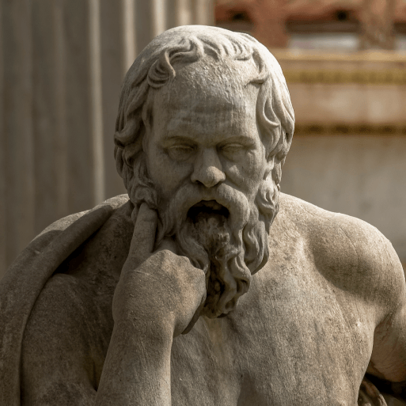  History Focus  Companion Projects  - Architecture  - Mixed Media  - Properties and Changes of Materials  - Expression | English | Maths | Science | Art | DT | Music
 | Greek myths; Balanced arguments; Playscripts; Odes | Statistical Reasoning 1  Roman Numerals, Time and Revision  Proportional Reasoning 3  Statistical Reasoning 2  Measures and Describing Patterns  Financial Maths and Enterprise  Solving Problems involving the Four Operations | Properties and Changes of Materials  Properties of materials; Thermal conductivity; Measuring temperature; Thermal insulators; Solubility; Heterogeneous and homogeneous mixtures; Sieving; Filtration; Evaporation; Separating unusual mixtures; Reversible and irreversible changes; Innovative materials; Working scientifically – Identifying and classifying, Observing changes over time, Comparative tests, Research, Pattern seeking | Mixed Media  Paper crafts; Papermaking; Paper, fabric, mixed media and surreal photo collage; Mixed media artwork.  Expression  Expressionist art movement; Significant artist – Edvard Munch; Portrait photography; Expression; Self-portraits | Architecture  Architecture over time; Greek architecture; Structural support, stiffness and stability; Computer-aided design; Building design.  Mixed Media  Fabric and mixed media collage; Stitching and embellishment | Understanding Structure and Form
 | Computing | Geography | History | PSHE | RE | PE
 | Using data | Interpreting geographical sources | Ancient Greek periods – Minoan civilisation, Mycenaean civilisation, Dark Age, Archaic period, Classical period, Hellenistic period; Chronology and timelines; Primary and secondary sources; City states; Democracy; Role of men and women; Social hierarchy; Great Athenians; the Acropolis; Greek art, culture, architecture, philosophy, medicine and mathematics; Olympic Games; Alexander the Great; End of the Greek Empire; Legacy | Relationships  Changing Me | Leaders in religious communities and the importance of religion today.  Creation stories and the ultimate questions they raise. | Outdoor and Adventurous Activities Unit  Athletics Unit  Tennis Unit  Rounders Unit
 | Memorable Experience  Time team  Details to be added when confirmed |  |  | Innovate Challenge  The ancient Greeks’ greatest idea

