Lower Key Stage 2 (Year 3 and Year 4) Cycle B
2022/23 and 2024/25
 | English | Maths | Science | Art | DT | Music
Autumn Term  Invasion  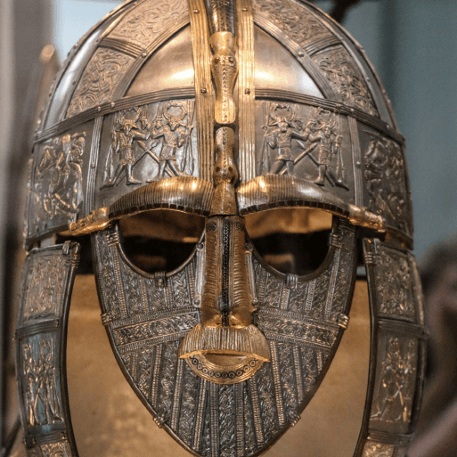  History Focus  Companion Projects  - Contrast and Compliment  - Interconnected World  - Fresh Food, Good Food  - Warp and Weft  - Digestive System  - Sound | Anglo-Saxon poetry; Playscripts; Norse myths; Non-chronological reports | Number and Place value  Additive Reasoning 1 – Mental Addition Additive Reasoning 2 – Mental Subtraction Multiplicative Reasoning 1 – Building Fact Recall  Proportional Reasoning 1 – Scaling, Comparison and Fractions Geometric Reasoning 1 – Angles and Lines | Digestive System  Unit not yet released  Sound  Unit not yet released | Contrast and Complement Colour theory; Colour wheel; Tertiary colours; Warm and cool colours; Complementary colours; Analogous colours.  Warp and Weft  Weaving; Exploring yarns | Food preservation techniques; Exploring food packaging; Prototypes; Designing, making and packaging healthy snacks | Let Your Spirit Fly  Listening and appraising music  Singing together - RnB theme. Playing recorders and percussion instruments as an ensemble.
 | Computing | Geography | History | PSHE | RE | PE
 | Staying safe online; Evaluating Digital Content | Geographical sources. Interconnected World - Compass points; Four and six-figure grid references; Tropics of Cancer and Capricorn; Countries, climate and culture of North and South America; Significant physical features of the UK; Renewable and non-renewable energy; National Rail network; UK canal network; Fieldwork; Local enquiry | Roman withdrawal from Britain; Chronology of invasion; Anglo-Saxon invasion; Anglo-Saxon kingdoms, beliefs and customs; Religion; Everyday life in Anglo-Saxon Britain; Viking invasion; Everyday life in Viking Britain; Significant people – King Athelstan; Norman invasion; Legacy | Being Me in My World  Celebrating Difference | Christianity, Hinduism, Sikhism  Belonging  Hindu teaching about God  How do Hindu’s worship their God in their home?  Christmas | Dance -  Dance Unit  Olympic Dance Unit  Games -  Netball Unit  Quiksticks Hockey Unit
 | Memorable Experience  The Ruin  Details to be added when confirmed |  |  | Innovate Challenge  Viking Hoard
Spring Term  Misty Mountain, Winding Rivers    Geography Focus  Companion Projects  - Vista  - Functional and Fancy Fabrics  - States of Matter  - Animal  - Grouping and Classifying | English | Maths | Science | Art | DT | Music
 | Diaries; Information leaflets; Explanations; Narrative poetry | Proportional Reasoning 2 – Adding and Subtracting fractions  Geometric reasoning 2 – Properties of 2-D shape  Additive Reasoning 3 – Formal Written Addition and Subtraction  Spatial Reasoning 1 – Perimeter  Statistical Reasoning 1 – Scaling  Multiplicative Reasoning 2 – Multiplicative Laws and Area  Multiplicative Reasoning 3 – Formal Written Multiplication and Division | States of Matter  Water cycle; Habitats; Changing environments. Classifying solids, liquids and gases; Unusual materials; Particle theory; Change of state; Melting, freezing, evaporation and condensation; States of water; Measuring temperature; Investigating melting; Line graphs; Researching melting and boiling points; Working scientifically – Observing changes over time, Identifying and classifying, Pattern seeking, Comparative test, Research.  Grouping and Classifying Types of classification; Taxonomy; Understanding and creating classification keys; Animal kingdom; Plant kingdom; Classifying new discoveries; Working scientifically – Identifying and classifying, Pattern seeking, Research | Vista  Landscape; Perspective. Functional and Fancy Fabrics  Motifs and pattern; Nature; Block printing; Embroidery. Animal  Significance of animals in art; Drawing; Printing, Clay sculpture | Mountain climbing equipment.  Fabrics; Design features; Significant designer – William Morris; Stitching a hem; Embellishment; Designing and making patterned and embellished fabrics | Enjoying Improvisation  What stories do music teach us about the past. Exploring music as personal expression through improvisation.
 | Computing | Geography | History | PSHE | RE | PE
 | Scratch; Algorithms and Debugging | Rivers; Maps; Grid references; Contour lines; Physical processes – erosion, transportation and deposition; World rivers; Aerial images;  Mountains; UK mountains; World mountains; Compass points; Water cycle; Soil; Altitudinal zones; Data analysis |  | Dreams and Goals  Healthy Me | Christianity, Hinduism, Sikhism  Belonging  The importance of food and sharing.  Easter | Gymnastics -  Unit 1  Unit 2  Fitness Unit  Sportshall Athletics
 | Memorable Experience  River visit.  Details to be added when confirmed |  |  | Innovate Challenge  Learn about the lakes
Summer Term  Ancient Civilisations  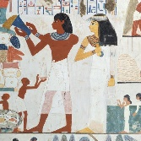  History Focus  Companion Projects  - Tomb Builders  - Statues, statuettes and figurines  - Electrical circuits and conductors  - Islamic Art | English | Maths | Science | Art | DT | Music
 | Free verse poetry; Instructions; Stories from other cultures | Number and Place Value 2 - Decimals  Measurement Reasoning 1 – Comparing, Estimating and Calculating with Measures  Measurement and Statistical Reasoning 2 – Time, Timetables and Time Graphs  Operational Reasoning – Understanding and Applying the Four Operations  Proportional Reasoning 3 – Finding Fractions of Continuous Quantities  Rolling Topics  • Roman Numerals to 100  • 3-D Shape – Building and Identifying Properties  • Symmetry | Electrical circuits and conductors  Sources of electricity; Electrical devices; Electrical components; Series circuits; Complete and incomplete circuits; Conductivity; Conductors and insulators; Wired plugs; Incandescent light bulbs; Future of electricity; Working scientifically – Identifying and classifying, Pattern seeking, Comparative test, Research | Statues, Statuettes and Figurines  Figure drawing; Statues, statuettes and figurines; Sculptures from ancient civilisations; Clay work and sculpting.  Islamic Art  Features of Islamic art; Motifs and patterns; High and low relief clay sculpture | Tomb Builders  Simple and compound machines.  Electrical Circuits and Conductors  Making switches; Programmable technologies; Programming a micro:bit; Designing and making a nightlight; Incorporating programming and circuits in products | Mamma Mia  learning to sing, play, improvise and compose with the song Mamma Mia,
 | Computing | Geography | History | PSHE | RE | PE
 | Programming  Programmable technologies; Programming a micro:bit; Designing and making a nightlight; Incorporating programming and circuits in products | Electrical Circuits and Conductors - Sustainable energy sources | Features of civilisations; Ancient Sumer; Ancient Egypt; Indus Valley civilisation; Artefacts; Timelines; New inventions and technology; Everyday life; Social hierarchy; Significant leaders; End of ancient civilisations | Relationships  Changing Me | Christianity, Hinduism, Sikhism  Special books and sacred texts  Sacred writing and stories | Outdoor and Adventurous Activities Unit  Athletics Unit  Quik Cricket Unit  Swimming at Hitchin Pool
 | Memorable Experience  What is a civilisation?  Details to be added when confirmed |  |  | Innovate Challenge  Exploring the Indus Valley Civilisation.

