Key Stage 1 (Year 1 and Year 2) Cycle B
2022/23 and 2024/25
 | English | Maths | Science | Art | DT | Music
Autumn Term  Movers and Shakers  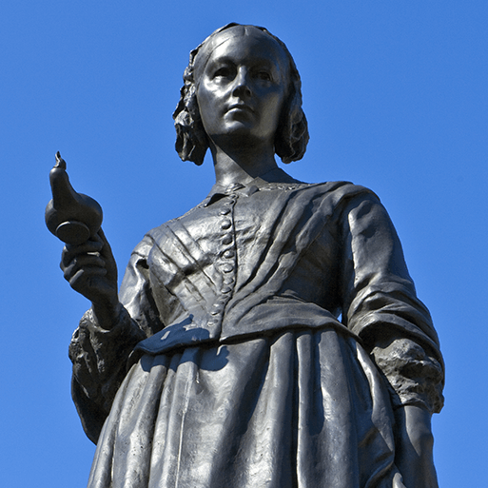  History Focus  Companion Projects  - Let’s explore the world  - Mix It!  - Still Life  - Remarkable Recipes  - Human Survival  - Habitats | Biographies; Newspaper reports; Persuasive posters; Speeches | Positional language and sequencing  Subitising - more and fewer  Number magnitude - estimation and comparison  Place value - making ten(s) and some more  Time - estimating, sequencing and comparing  Additive Reasoning - understanding language of operations  Part whole  Equity and comparison  Measuring length, height and mass | Human Survival  Unit not yet released  Habitats  Unit not yet released | Colour theory; Colour wheel; Primary and secondary colours.  Still life; Colour study; Compositions | Sources of food; Kitchen tools; Reading recipes; Hygiene rules; Making a school meal | Ho, ho, ho!  Listening and appraising music)  Singing together - Ho, ho, ho song. Plus Christmas production songs
 | Computing | Geography | History | PSHE | RE | PE
 | Staying safe online; Algorithms; | Historical landmarks; Significant places.  Using an atlas; Using a compass; Using map keys; Locating the equator, Northern and Southern Hemispheres and North and South Poles; Hot, temperate and cold places; Comparing England to Somalia; Sustainability; Fieldwork | Historical models; Exploring significance; Local historically significant person; Historical vocabulary; Chronology and timelines; Historically significant artists, activists, explorers, monarchs and scientists; Facts and opinions; Memorials; Significant people – Captain James Cook, Christopher Columbus, Claude Monet, Elizabeth Fry, Emmeline Pankhurst, Florence Nightingale, Henry VIII, Isaac Newton, Joseph Lister, Mahatma Gandhi, Marie Curie, Martin Luther King Jr, Mary Anning, Neil Armstrong, Paul Cezanne, Queen Victoria, Roald Amundsen, Rosa Parks, Vasco da Gama, Vincent van Gogh, William Shakespeare | Being Me in My World  Celebrating Difference | Signs and Symbols  Christmas | Dance -  Space Dance Unit  Winter Dance Unit  Games -  Ball Skills Unit  Multi-Skills Unit
 | Memorable Experience  Studying a local historically significant person.  Details to be added when confirmed |  |  | Innovate Challenge  Significant individual presentation.
Spring Term  Coastline  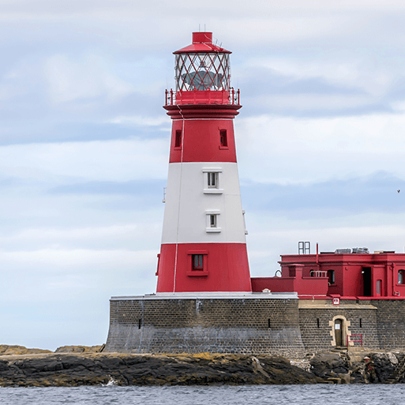  Geography Focus  Companion Projects  - Beach Hut  - Flower Head  - Use of materials  - Plant survival | English | Maths | Science | Art | DT | Music
 | Descriptions; Adventure narratives; Non-chronological reports; Persuasive writing | Geometry 1  Regrouping to Add and Subtract  Strategy Choices for Addition and Subtraction  Problem Solving with Addition and Subtraction  Doubling and halving  Multiplication – Counting, Multiples and Repeated Addition  Multiplication – Number of Groups, Group Size and Product  Division – Sharing and Grouping  Problem Solving with Multiplication and Division | Use of materials  Identifying materials and their properties; Shaping materials; Uses of materials; Linking properties to use; Sustainability and recycling; Working scientifically – Identifying and classifying, Pattern seeking, Comparative tests, Research.  Plant Survival  Plant parts; Seasonal changes in plants; Investigating germination; Investigating plant growth; Unusual plants; Working scientifically – Observing changes over time, Identifying and classifying, Pattern seeking, Comparative test, Research | Materials and techniques. Analysing artwork; Exploring visual elements – colour, shape, form, texture and pattern; Significant artist – Yayoi Kusama; Drawing; Printmaking; 3-D forms | Structures – strengthening and joining | Glockenspiel Stage 1  Improvise using notes, D, E and F. Play one of the differentiated parts following simple melody using notes C, D, E, F
 | Computing | Geography | History | PSHE | RE | PE
 | Scratch Junior  Programming and debugging (beebots); | Maps, globes and atlases; World seas and oceans; Human and physical features; Locational language; Compass directions; Physical processes – erosion; Changes over time; Tourism | Jobs in the past; Significant people – Captain Cook | Dreams and Goals  Healthy Me | Special Places  Easter | Gymnastics -  Unit 1  Unit 2  Pirate Fitness Unit  Dodgeball Unit
 | Memorable Experience  Coastal visit.  Details to be added when confirmed |  |  | Innovate Challenge  My coastal town
Summer Term  Magnificent Monarchs  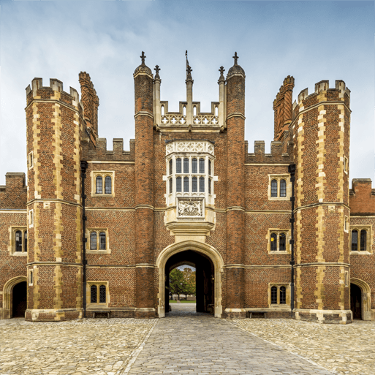  History Focus  Companion Projects  - Portraits and Poses  - Cut, stitch and join  - Animal Survival  - Push and Pull | English | Maths | Science | Art | DT | Music
 | Information leaflets; Kennings poems; Comic strips | Money  Fractions  Problem solving - all operations  Time - turns, telling time  Time - drawing hands on clock and intervals of time  Measures and reading scales  Statistics  Geometry 2  Place Value with larger numbers  Calculation review | Animal Survival  Unit not yet released | Portraiture; Royal portraits; Sketching; Digital artwork | Cut, Stitch and Join Everyday fabric products; Significant designer – Cath Kidston; Sewing patterns; Running stitch; Adding embellishments; Designing and making a bag tag. Push and Pull  Machines and mechanisms; Sliders, levers and linkages; Designing and making greetings cards with moving parts | Glockenspiel Stage 2  Learning the language of music through the glockenspiel. Beginning to use musical score.
 | Computing | Geography | History | PSHE | RE | PE
 | Using data; Using computers  Art software; Photography; Photo editing | Significant places – royal residences | Historical vocabulary; Historical periods; Timelines; Power and rule; Historical artefacts; Significant people - Alfred the Great, William the Conqueror; Henry VIII, Elizabeth I, Queen Victoria, Elizabeth II; Bayeux tapestry; Feudal system; Actions and impact; Historical models | Relationships  Changing Me | Religious Leaders  Easy Questions - Difficult Answers | Ball Games Unit  Athletics Unit  Quik Cricket Unit  Tennis Unit
 | Memorable Experience  English and British monarchy timeline.  Details to be added when confirmed |  |  | Innovate Challenge  Magnificent Monarchs board game.

