Key Stage 1 (Year 1 and Year 2) Cycle A
2023/24 and 2025/26
 | English | Maths | Science | Art | DT | Music
Autumn Term  Childhood  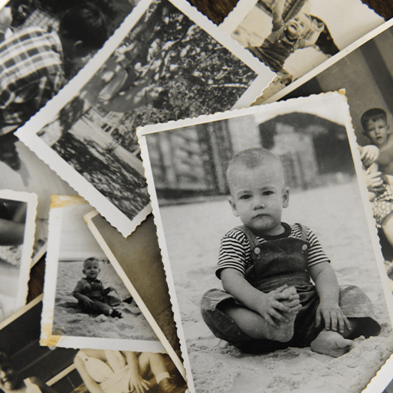  History Focus  Companion Projects  - Our wonderful world  - Mix It!  - Shade and Shelter  - Funny Faces and Fabulous Features  - Everyday Materials  - Human Senses | Autobiographies; Non-chronological reports; Riddles | Positional language and sequencing  Subitising - more and fewer  Number magnitude - estimation and comparison  Place value - making ten(s) and some more  Time - estimating, sequencing and comparing  Additive Reasoning - understanding language of operations  Part whole  Equity and comparison  Measuring length, height and mass | Everyday Materials  Naming everyday materials; Properties and uses of materials  Human Senses  Unit not yet released | Colour theory; Colour wheel; Primary and secondary colours.  Portraiture; Collage | Shade and Shelter - Investigating existing products; Designing and making shelters and dens; Prototypes; Safety rules; Materials.  Funny Faces and Fabulous Features - Stitching to join materials; Embellishing | In the Groove  Listening and appraising music  Singing together - In the groove song. Plus Christmas production songs
 | Computing | Geography | History | PSHE | RE | PE
 | Staying safe online;  Scratch Junior - tinkering  Programming and debugging (beebots); | Settlements; Changes over time.  Our Wonderful World Physical and human features; Picture maps; Cardinal compass points; Equator and hemispheres; Continents; Oceans; Countries and capital cites of the UK; Protecting natural environments; Fieldwork | Historical vocabulary; Historical artefacts; Timelines; Everyday life and childhood in the 1950s; Significant events – Queen's coronation; Enquiry | Being Me in My World  Celebrating Difference | Thanking God for nature  Light  Christmas | Dance -  Space Dance Unit  Winter Dance Unit  Games -  Ball Skills Unit  Multi-Skills Unit
 | Memorable Experience  Childhood past and present  Details to be added when confirmed |  |  | Innovate Challenge  Childhood Knowledge Organisers
Spring Term  Bright Lights, Big City    Geography Focus  Companion Projects  - Taxi  - Rain and Sunrays  - Seasonal Changes | English | Maths | Science | Art | DT | Music
 | Information posters; Directions; Adventure narratives | Geometry 1  Regrouping to Add and Subtract  Strategy Choices for Addition and Subtraction  Problem Solving with Addition and Subtraction  Doubling and halving  Multiplication – Counting, Multiples and Repeated Addition  Multiplication – Number of Groups, Group Size and Product  Division – Sharing and Grouping  Problem Solving with Multiplication and Division | Seasonal Changes  Seasons; Seasonal changes in deciduous and evergreen trees; Seasonal changes in animals; Weather; Seasonal weather; Day length; Investigating the Sun; Measuring wind; Measuring temperature; Measuring precipitation; Weather forecasting; Working scientifically – Observing changes over time, Identifying and classifying, Pattern seeking, Comparative test, Research | Drawing.  Motifs; Line and shape; Texture; Collagraphy | Taxi!  Mechanisms – wheels, axles and chassis | The Dragon Song  Learn and perform song together and accompany with glockenspiels and percussion instruments
 | Computing | Geography | History | PSHE | RE | PE
 | Searching the web; Algorithms; Logical reasoning; Programming; Common uses of information technology | Countries and capital cities of the UK; Physical features of the UK; Settlements; Human features; Weather and seasons; Landmarks; Aerial images; Locational language; Maps; Compass directions; Geographical similarities | Monarchy; Significant event – Great Fire of London | Dreams and Goals  Healthy Me | Belonging  Easter | Gymnastics -  Unit 1  Unit 2  Pirate Fitness Unit  Dodgeball Unit
 | Memorable Experience  Royal Role Play  Details to be added when confirmed |  |  | Innovate Challenge  Marley’s Trip to London
Summer Term  School Days  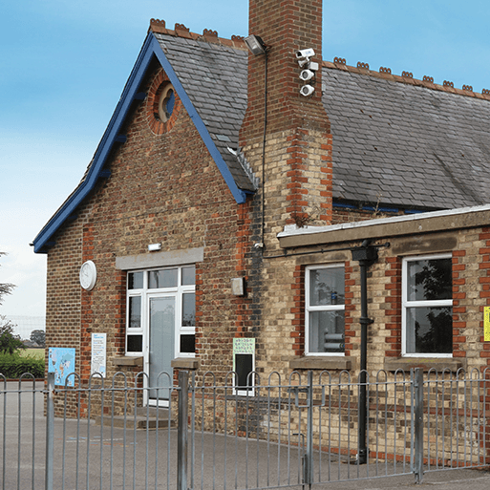  History Focus  Companion Projects  - Street View  - Chop, slice and mash  - Plant Parts  - Animal Parts | English | Maths | Science | Art | DT | Music
 | List poems; Diaries; Letters | Money  Fractions  Problem solving - all operations  Time - turns, telling time  Time - drawing hands on clock and intervals of time  Measures and reading scales  Statistics  Geometry 2  Place Value with larger numbers  Calculation review | Plant Parts  Wild and garden plants; Seasonal changes; Plant parts; Seeds and bulbs; Investigating leaves; Importance of plants; Working scientifically – Identifying and classifying, Observing changes over time, Pattern seeking, Research, Comparative test  Animal Parts  Unit not yet released | 3-D murals; Buildings; Significant people – James Rizzi | Chop, Slice and Mash - Sources of food; Food preparation techniques; Hygiene rules; Designing and making salads and sandwiches | Zootime  Learn and perform this reggae song together and accompany with glockenspiels and percussion instruments
 | Computing | Geography | History | PSHE | RE | PE
 | Using data;  Art software; Photography; Photo editing | Fieldwork; Human and physical features; Maps; Local environment; Changes over time | Historical vocabulary; Historical artefacts; Timelines; Present day schools; Our school; Victorian era; Victorian schools; Significant people – Samuel Wilderspin | Relationships  Changing Me | Books and stories | Ball Games Unit  Athletics Unit  Quik Cricket Unit  Tennis Unit
 | Memorable Experience  Our school’s history  Details to be added when confirmed |  |  | Innovate Challenge  Planning an Assembly

